**Step 1 :** Launch a windows server 2012 R2 t2.mirco plan Your windows instance Security group on EC2 SG-( should have below ports open)

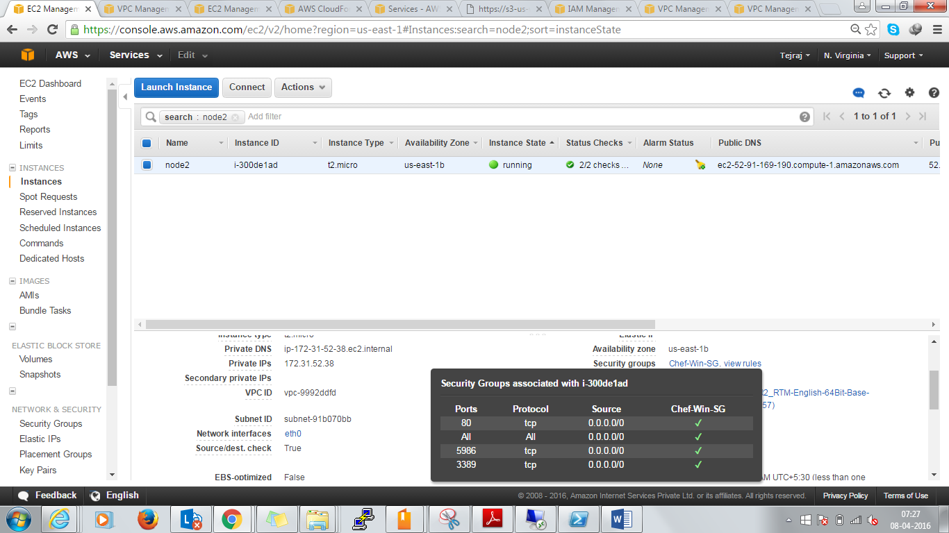

**Step 2 :** User data in EC2 script

<powershell>

$admin = [adsi]("WinNT://./Administrator, user")

$admin.psbase.invoke("SetPassword", "Ch4ng3m3")

winrm qc -q

winrm set winrm/config '@{MaxTimeoutms="1800000"}'

winrm set winrm/config/service '@{AllowUnencrypted="true"}'

winrm set winrm/config/service/auth '@{Basic="true"}'

Set-Item wsman:localhost\client\trustedhosts -value * -force

Get-NetFirewallProfile | Set-NetFirewallProfile -Enabled False

net stop winrm

sc.exe config winrm start=auto

net start winrm

</powershell>

**Step 3 : Bootstrap your windows server node**

knife bootstrap -N windows winrm 54.67.120.184 -m -x Administrator -P Ch4ng3m3

52.91.33.210

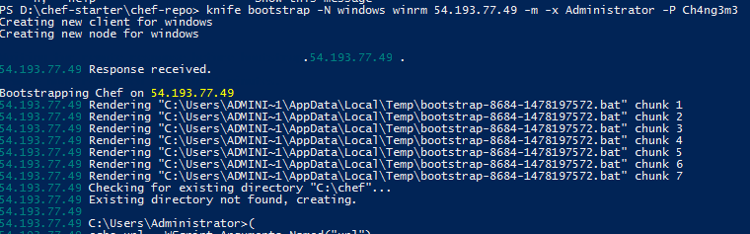

**Notes**

* 54.193.77.49 :: public IP of your node
* Ch4ng3m3 : password of your windows machine
* Some notable files downloaded on ur windows machine
* 52.207.247.59 powershell.exe -ExecutionPolicy Unrestricted -NoProfile -NonInteractive -File C:\chef\wget.ps1 "https://www.chef.io/chef/p=windows&pv=2012&m=x86_64&DownloadContext=PowerShell&v=12" "C:\Users\ADMINI~1\AppData\Local\Temp\chef-client-latest.msi"